Orange County Community College

Computer Science and Technology Department

**CSC 108 – Web Programming 1**

**Laboratory Exercise 2**

For our project we will be designing a simple IT helpdesk software.

There will pe different pages for a regular user to log in and report an issue.

Another page that will have the helpdesk supervisor to log in and see all the open and closed tickets.

Also, there will be another landing page for a regular IT helpdesk worker to log in and see their tickets that were assigned to them. Create a basic HTML webpage to have several pages and forms. At this time there will not be any pages that have a database backend. Keep in mind there will have to be modified later on to work with Django.

These are only mockup and each student should make their own design.

Main login page.

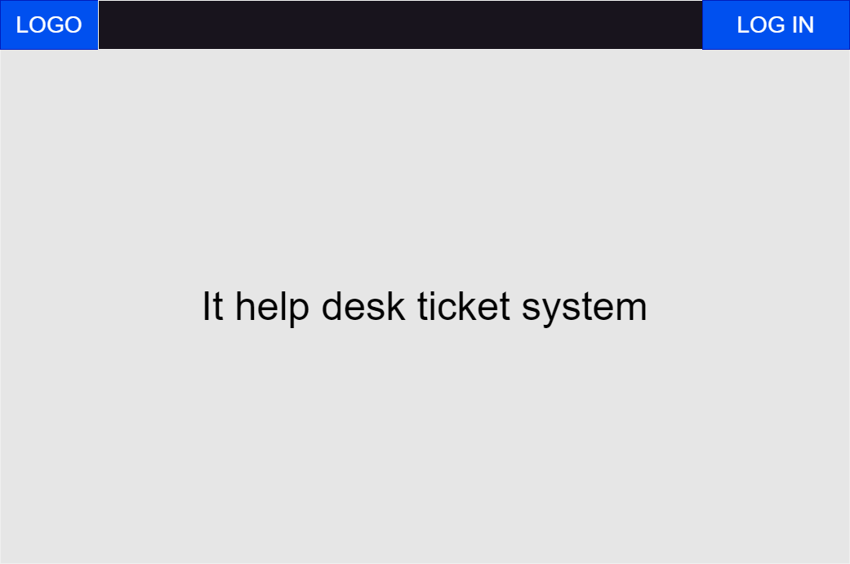

User landing page:

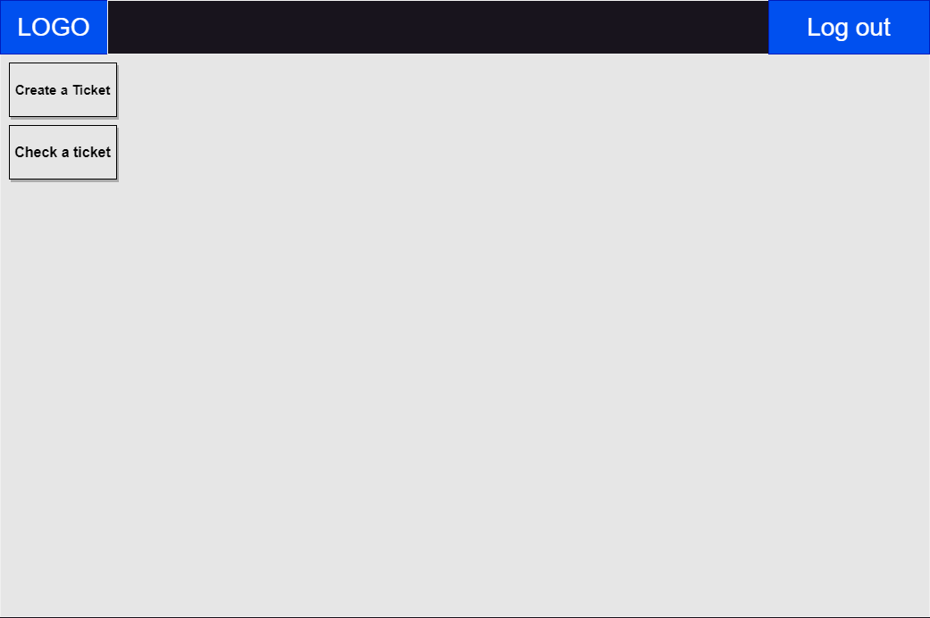

Create a ticket:

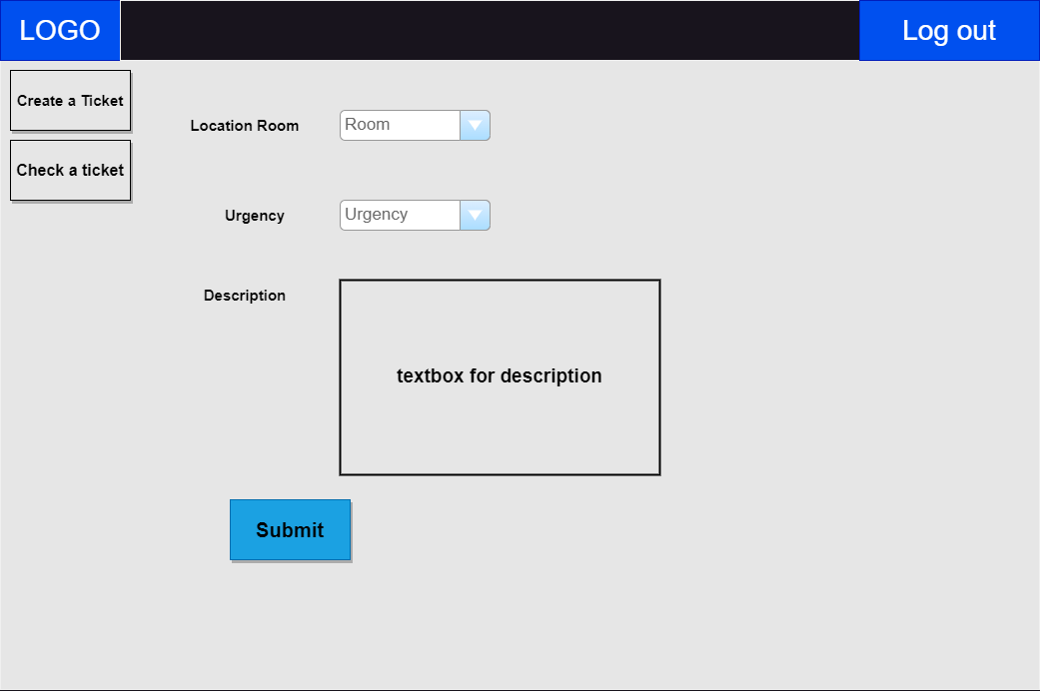

Check a ticket:

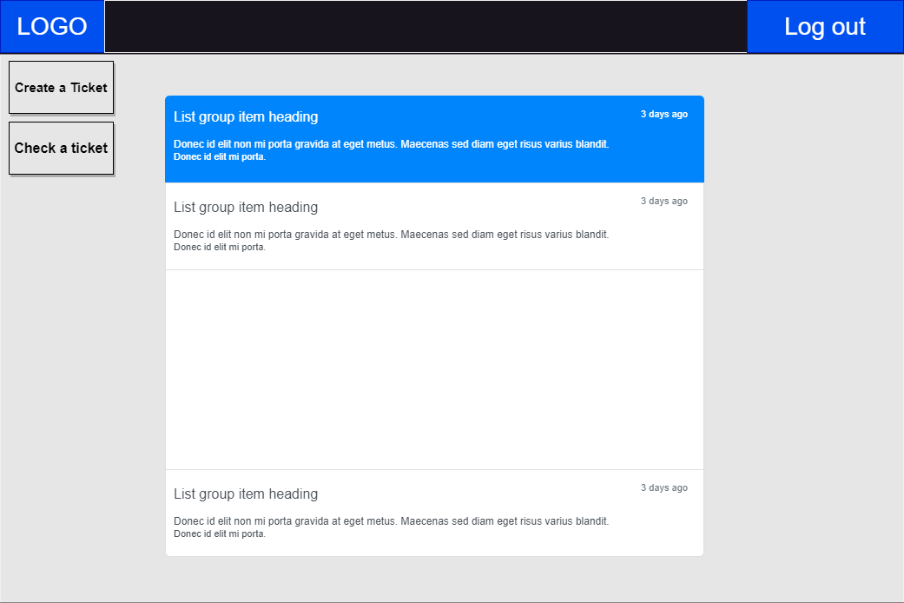

Admin ticketing. Assign a ticket to a worker.

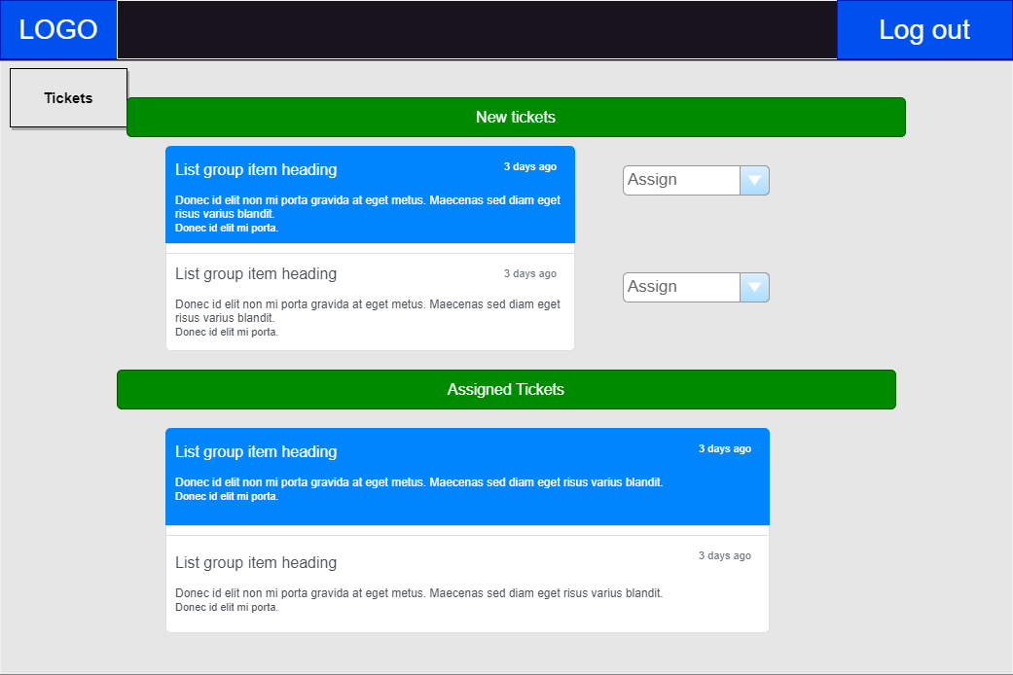

Worker tickets:

Landing page for IT workers:

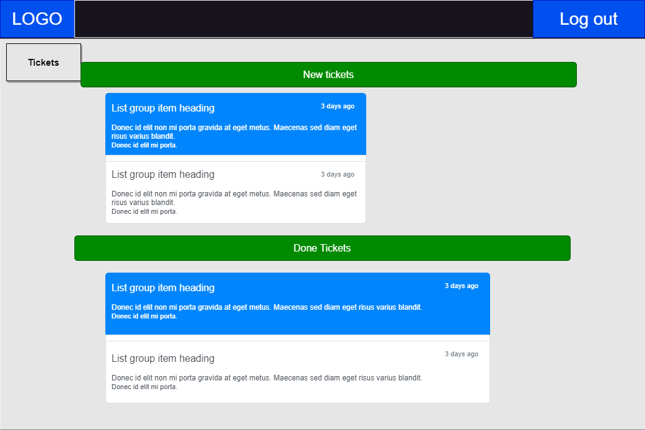

Clicking on a ticket:

